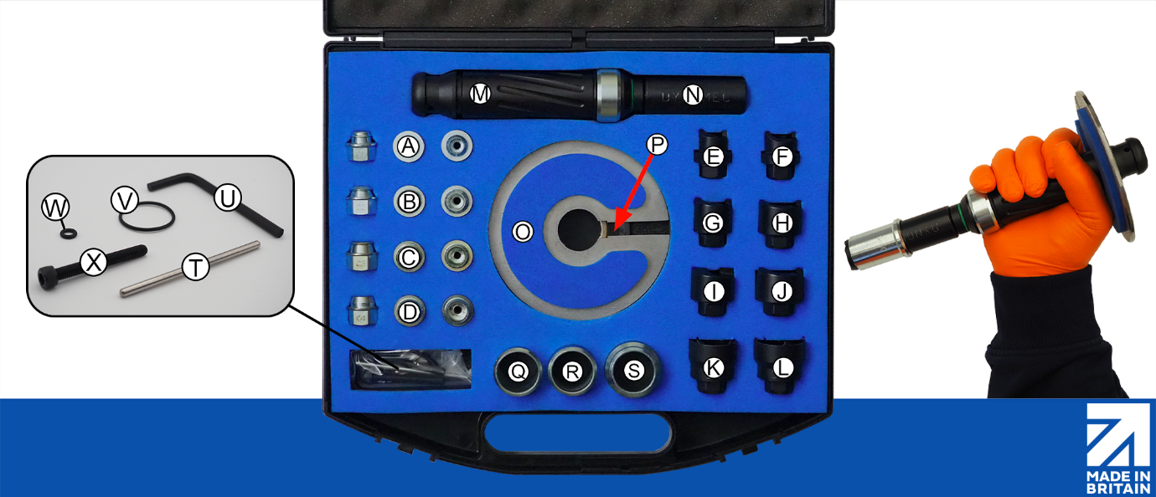
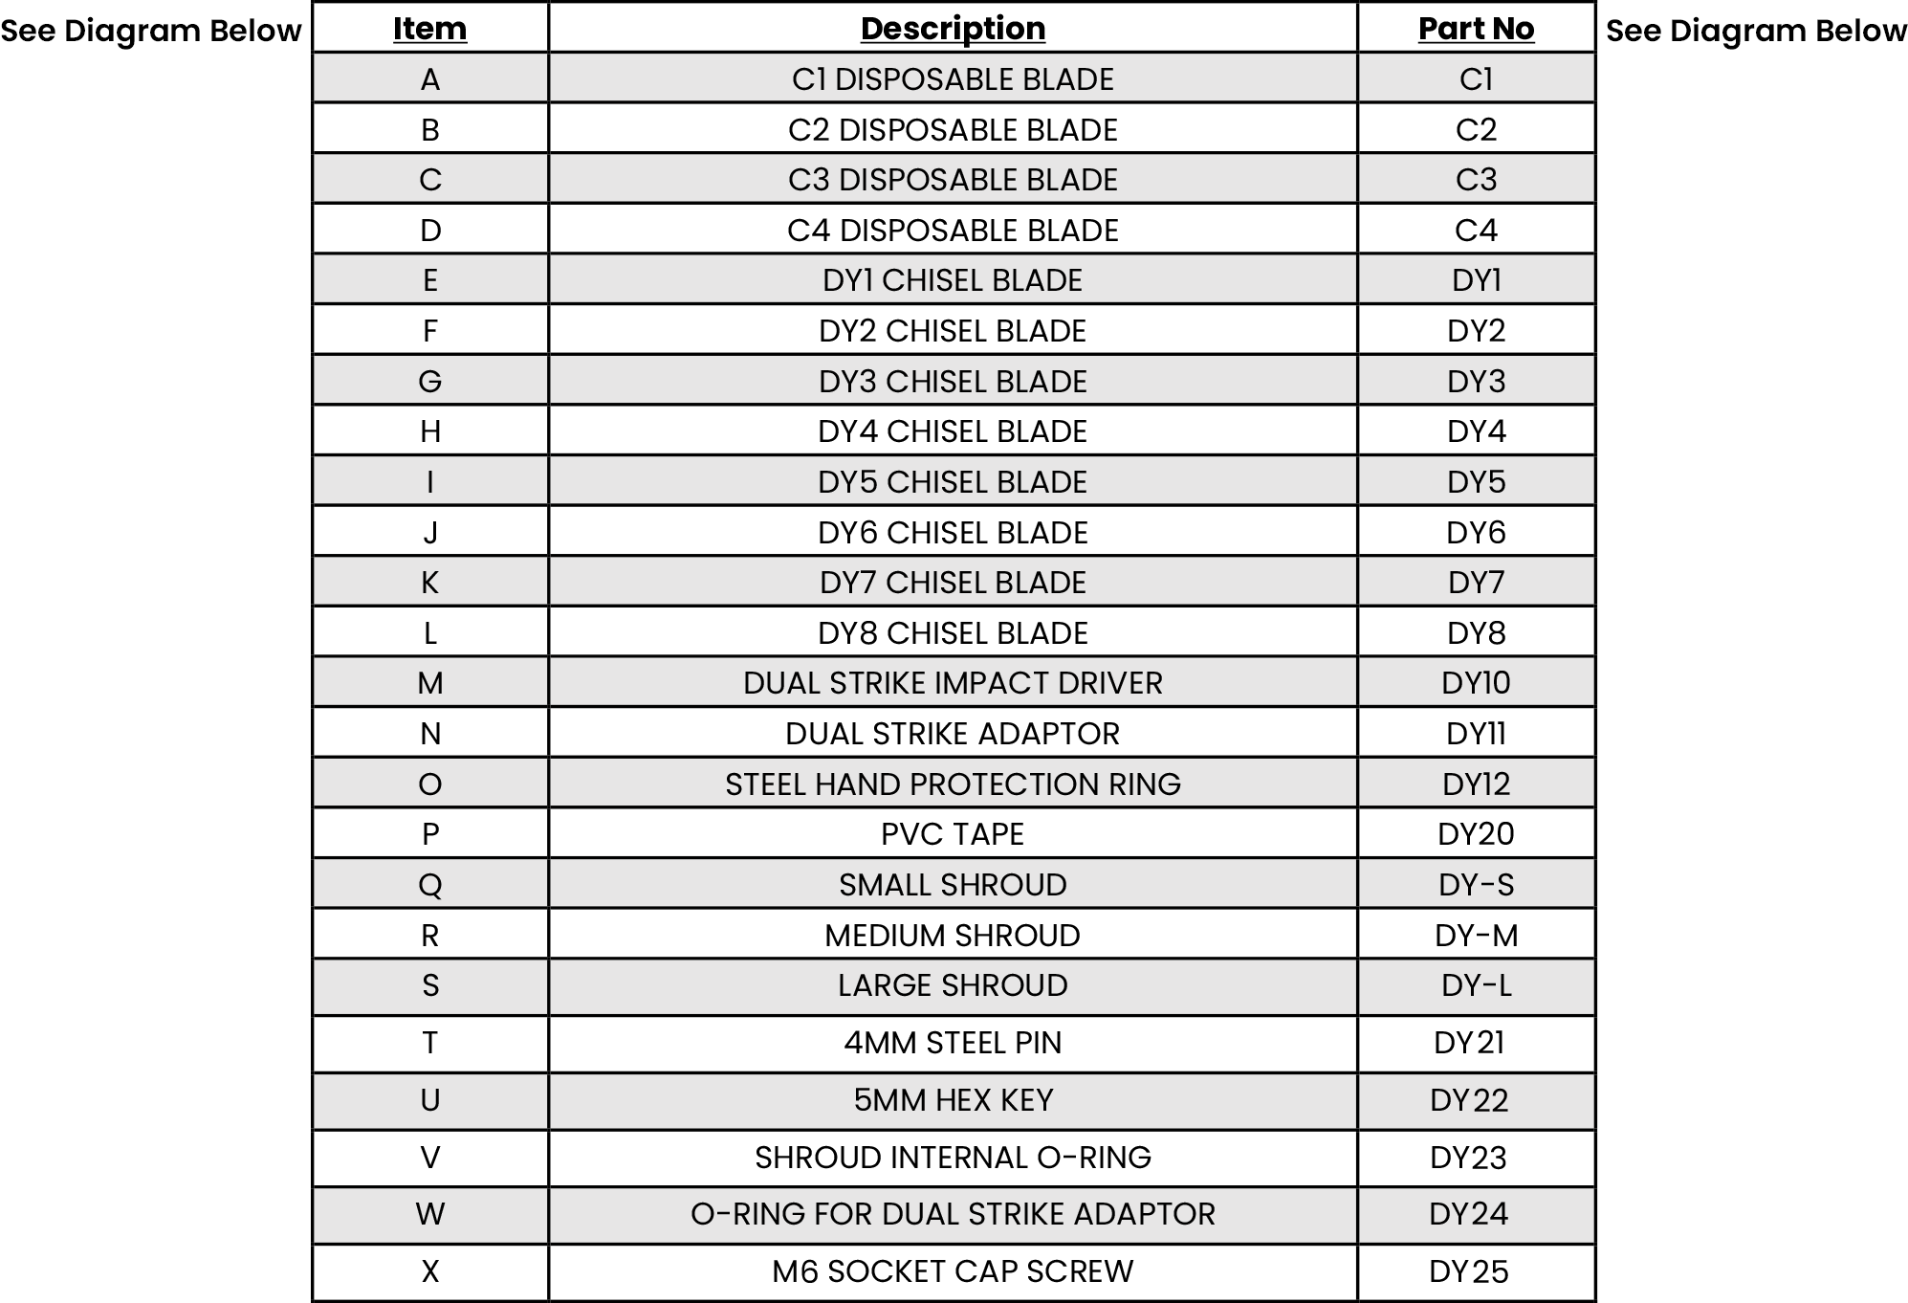
DY2300 PARTS LIST

Warning: The parts listed below are not interchangeable between DY1000 and DY2300 models. Please ensure compatibility when selecting and ordering components for your toolkit.

